**Point Plot:**

A point plot is used to visualize the relationship between a categorical variable (in this case, ssc_b) and a numerical variable (in this case, ssc_p), often with additional categorical variables (in this case, gender). The points represent the mean values, and the error bars indicate the confidence intervals.

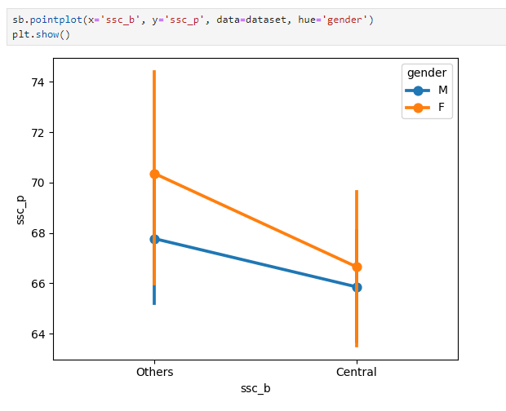

**Key Observations:**

1. **Board:**
   * **Others:** Students from the "Others" board have a slightly higher average secondary school percentage (ssc_p) compared to those from the "Central" board.
   * **Central:** Students from the "Central" board have a lower average ssc_p.
2. **Gender:**
   * **Others:** Within the "Others" board, male students have a slightly higher average ssc_p than female students.
   * **Central:** In the "Central" board, there's no significant difference in average ssc_p between male and female students.

**Additional Observations:**

* **Error Bars:** The error bars for the "Others" board are generally larger than those for the "Central" board, indicating greater variability in the data.
* **Overall Trend:** The overall trend suggests that students from the "Others" board, especially male students, tend to have higher average secondary school percentages.